Methodology
The methodology presented here is based upon the Capital Value Process which uses 6 generic phases. At the end of each phase there is a decision gate (M). A M is a milestone where line management decides either to approve the project to proceed to the next phase or to stop the project. The model is suitable for all types of projects.
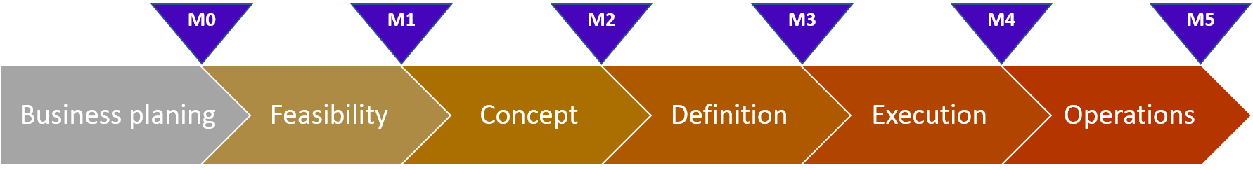

The business planning phase is to validate and document business ideas and provide enough basis to decide whether the project idea should be matured further. The business planning takes place before the project feasibility study. The work prior to the project initiation is done by the business and should document business ideas including the first version of the business case to provide enough basis to decide whether a project opportunity should be matured further during the project feasibility study phase. Relevant documents include the project proposal and the business case. The project proposal will include a definition of the expected scope, a preliminary cost and time estimate, and preliminary assessment of the resource requirements.

M0 is where the project owner takes the decision to start the feasibility phase. The purpose of M0 is to ensure that the feasibility phase is based on an idea for a business opportunity that is assessed to be aligned with the business direction of the organization, and that it is initiated and procured in a business-oriented manner.

The feasibility phase is the preparatory phase in the project model, prior to starting the project formally. In the feasibility phase, an investigation of a business opportunity is done. All relevant commercial, technical and organizational aspects are considered and addressed, including any risks and opportunities they could include. This phase should provide enough information to enable a decision to be made to start a formal project.

M1 is where the project owner takes the decision to start the formal project. The purpose of M1 is to ensure that the Concept phase is aligned with the business direction of the organization, that it is initiated and procured in a business-oriented manner, and that the benefits for the business are considered.

The concept phase is the phase in the project model where the project is outlined and preparations for successful project completion are made. The concept phase includes definition of the project goals, the project scope, the project organization (including roles and responsibilities), the project cost estimate and the project plans in order to provide a solid foundation for successful project execution and completion.
M2 is where a decision is made to start the Definition phase. The purpose of M2 is to ensure that project execution is based on a business case aligned with the business direction of the organization where the benefits for the customer are considered. It is also the main decision gate before, in large extent, involving external resources.

The definition phase develops the project ready for the execution phase. The purpose of the definition phase is to define the requirements and finalize the scope of the project, thus finalising the time and cost, so that a M3 decision can be made.

M3 is where a decision is made to start the Execution phase. The purpose of M3 is to approve the final scope, cost and time of the project. The execution phase develops the project further towards handover to the customer.
The purpose of the execution phase is to follow the plan in order to reach a formal decision to hand over the result of the project.

M4 represents a decision to start the operational verification and hand-over of the result of the project. The purpose of M4 is to make a go/no-go decision as to whether the project is ready to hand over its result. There can be several M4s, if the project plans to roll out in phases, one country at a time or parts of the result in succession.

The operations phase consists of verification and acceptance of the result of the project prior to close-down. The purpose of the operations phase is to verify that the result of the project is acceptable, that any errors or inconsistencies are dealt with and any remaining actions are handed over to another project, the operations department or the business.

M5 represents a decision to close the project. The purpose of M5 is to finalize hand-over and close the project. This includes transfer of responsibility to the customer and the operational responsible, return of project resources to their base and finalizing of project cost. The M5 decision must include the financial overview of the total project cost, including any pending costs received after the project work has stopped as well as how and by whom these costs will be followed up.

Communication
Communication management is the knowledge area that employs the process required to ensure timely and properly generation, collection, distribution, storage, retrieval, and ultimate disposition of project information.
Objectives
Most projects should have a communication management plan. This plan describes the communication strategy for the project – how communication should be managed in the project.

All projects must have a communication plan. This is a detailed plan that points out who should communicate to whom, when and how.
Consider using a communication log to keep track of communication from the project.

Important tasks and actions
The basis for a communication plan is a stakeholder analysis. The stakeholder analysis should be provided at M1 and updated at each relevant M. Projects with many stakeholders, many stakeholder organisations, international projects and/or are dependent on close cooperation with stakeholders for any reason should use the templates provided below.
The project manager is responsible for:
- Developing and suggesting a communication strategy
- Planning communication management in the project
- Implementing the plans for communication
- Making it possible for project members to access relevant information and to develop relations with other project members, as well as with other stakeholders
- Evaluating and improving the communication in the project.
Important decisions must be approved by the project owner or the steering committee before they are communicated.
The communication plan is worked out early in the project process and should be based on the stakeholder analysis.
A stakeholder analysis should be provided at M1 and updated at each relevant M. Invite the project team and important stakeholders to the project kick-off meeting.
Run the Communication management presentation in the project team.
Documents
- Communication management plan
- Communication plan
- Communication log (Word format)
- Stakeholder analysis I
- Communication guidelines
- Communication management presentation
- Status report

Cost
Estimating the scope of the project is often a time-consuming and complex activity, but it forms the basis of your project schedule and budget.
Objectives
- Provide reliable and accurate cost and time estimates for projects.
- Provide an estimating process for estimating costs and time.

Important tasks and actions:
All projects (except Scrum projects) should have a scope definition document to be estimated as good as possible at each M (or whenever feasible). You should have control of your scope at any time, so you know when you are using the planned contingency.
Add contingency according to the following guideline:
M | Phase | Cost estimate accuracy  at 80% confidence interval 1) | Normal level  of contingency 2)
M0 | Business planning | N/A | Not given
M1 | Feasibility | -40%/+40% | 25%-40%
M2 | Concept | -30%/+30% | 15%-30%
M3 | Definition | -20%/+20% | 10%-20%
1) The confidence interval is an expression for the accuracy of the estimate
2) More contingency may be acceptable for high risk projects – based on cost risk analysis.
Use peer review for quality assurance of the project estimate. Peer review is best done by a project manager who has experience from similar projects. (Peer review is a generic term that is used to describe a process of self-regulation. The purpose of a peer review is to maintain standards, improve performance, and provide credibility.)
Estimating operational costs is equally important as to estimate project costs. This forms an important basis for estimating Total cost of Ownership (TCO) for projects.
The method “Successive Calculation” or the “Lichtenberg method” could be used for cost estimates. Use the project cost or operational cost worksheets in the Excel spreadsheet “Cost and benefit template” for estimating costs and time.
Documents
- Cost and benefit template
- Estimating costs and resources
- Estimating plan
- Estimating report

Organisation
Below you find a short description of the most important project roles:
Project owner
- The project owner is the manager responsible and accountable for the business case and for securing good and consistent investment project decisions.
- The project owner shall ensure alignment of all activities, projects, operations and commercial aspects regarding the asset, including stakeholder management.
- Project owner involvement and clearly defined roles and responsibilities are essential for the success of any investment project.
- The project owner is responsible for the establishment of the steering committee and will chair this committee.
- The project owner assigns the responsibility for the project to the project manager.

Steering committee
- The Steering committee mandate is to secure alignment between stakeholders regarding definition of the business case.
- The steering committee will act as a board for the business case, manage assumptions and frame agreed in stakeholder start-up meeting. Main issues are risk- and stakeholder management, and strategic change management for relevant project assignments.
- The steering committee consists of key stakeholders who are appointed to follow up the investment project on key issues previously agreed in the stakeholder start-up meeting.
- The project owner is responsible for the establishment of the steering committee and will chair this committee.
- The steering committee decides the key directions, follow up the project’s critical areas and key risks.
- The steering committee members represent a link between the project and the business areas they represent and ensure its ownership to the projects work.
- The steering committee can be established for one, or a portfolio of investment projects.

Project manager
- The project manager is responsible for delivering the project results.
- The project owner assigns the responsibility for the project to the project manager.
- The agreement between project owner and project manager is written in the Project assignment.
- The project manager will be responsible for delivering a defined scope.
- For one business case or investment project there might be several project managers responsible for defined sub-projects.
- The project manager reports normally to the steering committee, but for small projects it can be enough to report to the project owner.

Project team members
- The project team members are responsible for carrying out work according to project plans.
- The project team members must be updated on project methodology and best practice.
- The project team members must report periodically to the project manager.

Product owner, Scrum team members, Scrum master
- Follow this link for more information about Scrum and roles.
Documents
- RACI-matrix – Example
- Resource matrix – Template
- Project organisation – Checklist

Procurement
Procurement management includes the process of acquire the products, services, or results needed from outside the project team to perform the work.
All procurement should be performed by the company’s procurement personnel. The professional negotiators invite bids to obtain favourable prices and terms. The employees themselves should never negotiate with suppliers, as this may spoil the company’s negotiation position. If your unit needs to test out, hire or purchase goods or services, contact the procurement unit.
Purchases without procurement authority may cause problems for the company. Violation of the EU rules for competitive bidding, for example, may result in heavy fines for the company.
It is important to perform procurements to secure best terms for the company, on short and long term. Main rule should be competition amongst 3 or more suppliers.
Important tasks and actions
- For projects intending to procure goods or services from external suppliers, it is important to involve the procurement organisation as early as possible for clarification and planning (at M1 if possible).
- A Procurement plan should be made at M2 and updated at M3, if applicable.
- A procurement manager should be appointed from the procurement unit. He/she should be responsible for developing the procurement strategies, in cooperation with the project manager and project team.
Documents/links
- Procurement plan – Template
- Procurement strategy

Quality
Quality assurance is the application of planned, systematic, quality activities to ensure that the project will employ all processes needed to meet requirements.
Objectives
The Quality management plan (QMP) is part of Quality assurance. The purpose of the QMP is to ensure the quality of the project’s deliverables and final project outcome. The plan must be continuously reviewed according to needs.

Quality management activities
The Quality management plan consists of two main activity types:
- Quality assurance (QA) activities – i.e. proactive activities with the goal of ensuring that reasonable and realistic plans are made by the project, and of building quality into project processes and deliverables.
- Quality control (QC) activities – i.e. activities with the goal of monitoring specific project deliverables or project processes to determine whether they comply with relevant quality standards (i.e. requirements) and identifying ways to eliminate causes of unsatisfactory performance
Within these two main activities there are sub activities related to:
- Project management – i.e. activities focusing on project technical matters such as mandates, project planning, project management, and project execution.
- Customer – i.e. activities focusing on user and customer related matters. Focus is on the use of the solution, e.g. usability, functionality, etc
- Product – i.e. activities focusing on technical matters. Focus is on the technical solution.

Quality management roles
Role | Responsibility
Steering committee (SC) – Decisive | - Approve the Quality management plan  - Approve results from QC  - Overrule the project manager in quality management matters, when there are enough reasons. E.g. demand QC activities and reject QC results.  - Allocate the required quality management resources to the project (assumption: the line organization is represented in the steering committee).
Project manager  (PM) – Advisory | - Develop the total Quality management plan containing both QA- and QC activities  - Get the Quality management plan approved by the steering committee  - Organize and inform the quality management participants  - Inform the project team and other stakeholders of the contents of the Quality management plan  - Coordinate and execute both QA- and QC activities according to the Quality management plan  - Assess the need for further proactive activities and QC activities based on the project performance  - Approve completed proactive activities  - Communicate results from proactive activities to the steering committee, the project team and other stakeholders  - Communicate results from QC activities to the project team  - Involve the relevant leading advisers when necessary.
QC coordinator – Advisory | - Receive all results from QC activities  - Communicate results from QC activities to the project manager  - Coordinate the steering committee’s handling of QC issues and results  - Advise the steering committee in QC issues and results
QA responsible – Advisory | - Develop and follow-up the Quality management plan on behalf of the project manager  - Undertake activities listed for the project manager  - Participate in QA activities

Documents
- Quality management plan

Risk
Risk management is a continuous process which involves all project members throughout the project lifecycle. The project must always focus upon identified project risks and opportunities and continuously try to identify new risks and opportunities.
Objectives
The key elements of the risk management process include risk identification, risk assessment, response action and monitoring risks and actions.

Important tasks and actions
It is important to include potential project opportunities in the risk management process. Project opportunities must be analysed and monitored in the same way as project risks.
Risk responsible will normally be the project manager, but for large projects this task could be given to a risk manager. Risk manager’s primary objective is to understand and manage threats and potential opportunities facing the project.
Tools
RiskyProject from Intaver Institute is an excellent tool to handle risks in a project. Prosjektservice is exclusive vendor for the products from Intaver in Norway.
Documents/links
- Risk checklist
- Risk matrix
- Risk table and actions

Risk management process
The key elements of the continuous risk management process in projects include risk identification, risk assessment, risk response action and risk monitoring.
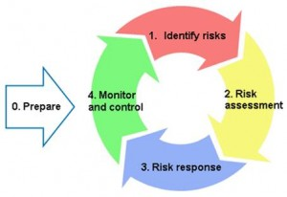
Important tasks and activities
The continuous risk process is NOT a task for the risk manager only. This is a bottom-up process in the project team where all team members contribute.
The process is initiated and followed up through project meetings. These meetings should be performed on a regular basis, at least before each status report.
0. Prepare
Before you start the continuous risk management process project it is recommended to carry out arrangements which involve and prepare as many project members as possible on possible upcoming threats (risks) and project potentials (opportunities).
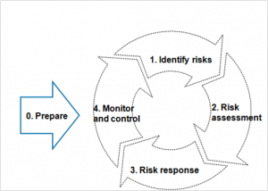
It is recommended to use the risk checklist to give ideas and to discover different project risks and opportunities.
Examples of arrangements:
- Kick-off meeting with focus on risk
- Workshop with brainstorming sessions on risk
Risk responsible will normally be the project manager, but for large projects a risk manager must be nominated by the project manager.
Other preparing tasks for the risk manager:
- Look at similar projects to get ideas of possible risks or opportunities. Encourage and facilitate cross-learning trough similar projects for all the project members.
- Set up an environment for risk management in the project.
- Use the given tools as risk table, risk checklist and risk matrix.

1. Identify risks
The project team must continuously identify both the threats and opportunities that can affect the project objectives.
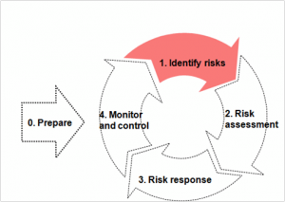
Each risk must be well defined and relate specifically to an undesired event (threat) or to a desired event (opportunity). Any new risks or issues should immediately be communicated to the risk manager
Risk identification must be an ongoing process and project members should be encouraged to openly communicate risks, not only in the meetings where risks are discussed.
Identified risks need to be described and registered. The risk register must be updated regularly as the project develops, and not just prior to passing each decision gate. Use the project risk table to register the identified risks. It is important to include potential project opportunities and not only project risks. Project opportunities must be analysed and monitored in the same way as project risks.
For large projects with many registered risks it is recommended to group the risks into sub-groups.
2. Risk assessment
The purpose of the risk analysis is to gather information about identified risks. You can then use this information to rank the risks by weighting them with the factor’s probability and consequence.

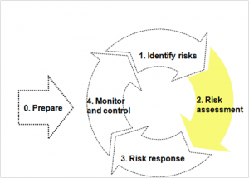
Risk analysis is a continuous process conducted throughout the project lifecycle. As the project progresses the analysis for a risk event might change due to changes in the environment.
The project team evaluates all registered risks of current interest in regular risk meetings. This is called risk assessment, where project members evaluate/weight and rank project risks.
The outcome of the risk assessment is entered into the project risk table. The project risk table should be used actively by the risk manager throughout the project.
Once risks are identified and assessed, a specific set of actions needs to be taken to mitigate threats and pursue opportunities in the project.
Each risk is registered and managed under the responsibility of a risk owner. However various actions to efficiently mitigate risks can be delegated to other team members who then would be assigned the responsibility of action owner.
The risk status must be communicated to the steering committee in a risk matrix. The risk matrix is part of the status report which the steering committee receives on a regularly basis.
It is of great importance that the project team works continuously with the risks and gets all risks into the “green area” of the risk matrix.
Risk analysis includes:
Evaluating
Estimate the probability that a risk event will occur and the resulting consequences. Then you use these estimates to determine the severity of the risk to the project.
Prioritizing
After determining risk severity, you decide the order in which the risks require attention. The highest ranked risks or opportunities are reported to the steering committee.
Weighting of impacts and probabilities
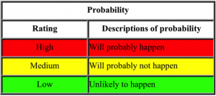

Consequence/Impact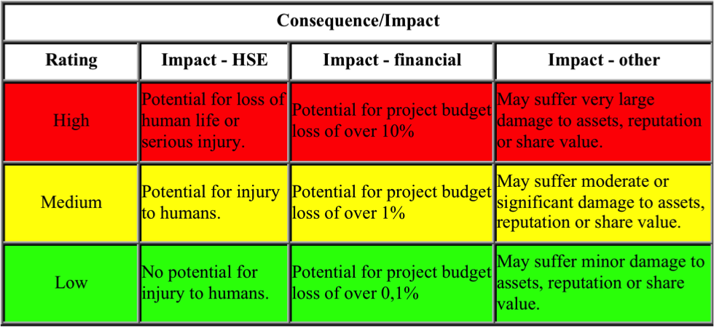

3. Risk response strategies
Once risks are identified and assessed, a specific set of actions needs to be taken to mitigate threats and pursue opportunities in the project.
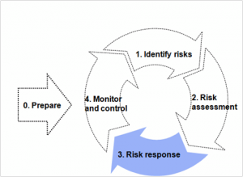
Each risk is registered and managed under the responsibility of a risk owner. However various actions to efficiently mitigate this risk can be delegated to other team members who then would be assigned the responsibility of action owner. For each mitigating action a deadline (due date) must be specified. It will be the responsibility of the risk owner to secure that actions are completed on time.
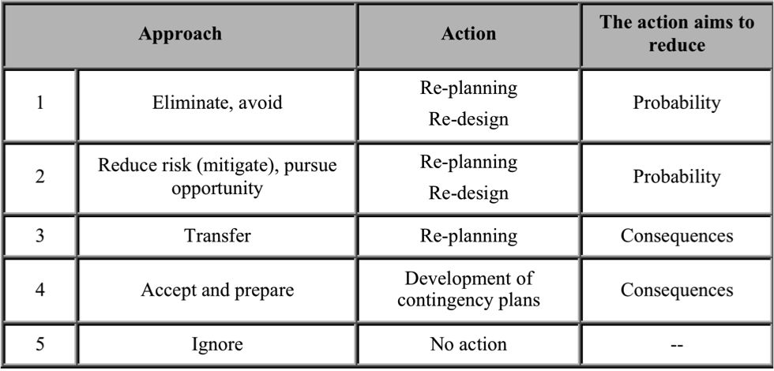

Strategies for negative risks or threats

1. Avoid: Risk avoidance involves changing the project management plan to eliminate the threat posed by an adverse risk, to isolate the project objectives from the risk’s impact, or to relax the objective that is in jeopardy, such as extending the schedule or reducing scope. Some risks that arise early in the project can be avoided by clarifying requirements, obtaining information, improving communication, or acquiring expertise.

2. Transfer: Risk transference requires shifting the negative impact of a threat, along with ownership of the response, to a third party. Transferring the risk simply gives another party responsibility for its management; it does not eliminate it. Transferring liability for risk is most effective in dealing with financial risk exposure. Risk transference nearly always involves payment of a risk premium to the party taking on the risk. Transference tools can be quite diverse and include, but are not limited to, the use of insurance, performance bonds, warranties, guarantees, etc. Contracts may be used to transfer liability for specified risks to another party. In many cases, use of a cost-type contract may transfer the cost risk to the buyer, while a fixed-price contract may transfer risk to the seller, if the project’s design is stable.

3. Mitigate: Risk mitigation implies a reduction in the probability and/or impact of an adverse risk event to an acceptable threshold. Taking early action to reduce the probability and/or impact of a risk occurring on the project is often more effective than trying to repair the damage after the risk has occurred. Adopting fewer complex processes, conducting more tests, or choosing a more stable supplier are examples of mitigation actions. Mitigation may require prototype development to reduce the risk of scaling up from a bench-scale model of a process or product. Where it is not possible to reduce probability, a mitigation response might address the risk impact by targeting linkages that determine the severity. For example, designing redundancy into a subsystem may reduce the impact from a failure of the original component.

4. Accept: The project has decided to do nothing with the risk.

Strategies for positive risks or opportunities

1. Exploit: This strategy may be selected for risks with positive impacts where the organization wishes to ensure that the opportunity is realized. This strategy seeks to eliminate the uncertainty associated with a upside risk by making the opportunity happen. Directly exploiting responses include assigning more talented resources to the project to reduce the time to completion, or to provide better quality than originally planned.

2. Share: Sharing a positive risk involves allocating ownership to a third party who is best able to capture the opportunity for the benefit of the project. Examples of sharing actions include forming risk-sharing partnerships, teams, special-purpose companies, or joint ventures, which can be established with the express purpose of managing opportunities.

3. Enhance: This strategy modifies the “size” of an opportunity by increasing probability and/or positive impacts, and by identifying and maximizing key drivers of these positive-impact risks. Seeking to facilitate or strengthen the cause of the opportunity, and proactively targeting and reinforcing its trigger conditions, might increase probability. Impact drivers can also be targeted, seeking to increase the project’s susceptibility to the opportunity.

4. Monitor and control
As a result of the risk assessment and suggested response actions, project plans must be updated.
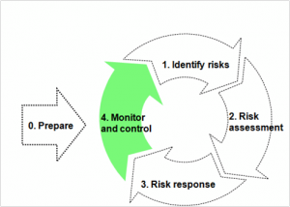
Risk monitoring is the process of keeping track of the identified risks, monitoring residual risks, and evaluating their effectiveness in reducing risks. Status on risks, opportunities and response actions should be followed up and documented regularly in order to secure efficient and effective risk management control.
The risk manager should establish standard routines for monitoring and control to ensure that all identified actions are mitigated with regards to action responsibility and deadline.
Reporting system allows leadership to be aware of main risks as well as possibilities and enable control of the quality of work.
Documents
- Risk checklist
- Risk matrix
- Risk table and actions

Scope
Scope management defines the procedures by which the project scope may be changed. It includes the paperwork, tracking systems (tools), information systems, and approval levels necessary for authorizing changes.
Objectives
The purpose of the scope change control process is always to have documented control over the project scope. Scope change control is one of the most important project management processes. A missing or incomplete scope change control process is one of the major reasons why projects are delayed, exceed their budgets and /or never are completed. If the project has adequate scope change control procedures, it is very likely that the agreed project delivery parameters will be satisfied. The major challenge is often not to develop the scope change control procedures, but to follow them.

Important tasks and actions
- Provide a Scope change log
- Document all scope changes in the Scope change request template.
Documents
- Scope change log
- Scope change request – Template

Social responsibility
Corporate social responsibility (CSR) defines the standards and guidelines for the group for social risk management, human rights, labour standards, transparency, and local content.
Project Managers should ensure that the customer´s activities are conducted in accordance with governing documents.
Corporate Social Responsibility consists of the following elements:
- Social risk management
- Human rights and labour standards
  - Freedom from discrimination in employment
  - Freedom of association and the right to collective bargaining
  - Prohibition on forced or compulsory labour
  - Prohibition on child labour
- Transparency and anti-corruption
- Local content
- Social investment management
- CSR plans

1. Social risk management
Social risk management is a continuous process and a foundation of corporate social responsibility. Social risks comprise the potential harmful effects of both unintentional incidents and planned activities from the customer´s operations on society. This also comprises external risks to the customer’s reputation.
Social risks and stakeholders must be identified and monitored throughout the decision-making process, and appropriate mitigation measures shall be implemented. Local, national and international stakeholders must be consulted and engaged, and measures to mitigate risk must be identified as part of the decision-making basis.
2. Human Rights and Labour Standards
The customer should support the International Bill of Human Rights, including the Universal Declaration of Human Rights, and the ILO Declaration on Fundamental Principles and Rights at Work, and will respect these rights throughout its operations.
The customer and its suppliers must comply with international labour standards.
3. Transparency and anti-corruption
The customer should respect and promote transparency through publishing of income, expenditure and taxes in all its country operations, and through integrity due diligence procedures, contracts and agreements, and the training of staff, suppliers and partners.

4. For Local content
Includes local recruitment, local procurement and local actions to promote social and economic benefits of the company´s operations.

5. Social investment management
Social investments contribute to the realisation of the customer´s ambition to undertake social responsibility, help to build the customer´s operations, and mitigate social risks,
6. CSR plans
CSR plans provide the strategic framework for implementation CSR activities to address social risks and promote mitigation. An annual CSR Country or Project CSR Plan is prepared by the country or project managers when the customer is present and has undertaken or prepares to undertake investments in non-OECD countries or when the customer prepares a project with high political or reputation risks in any country.
External resources
- Norwegian construction sector suppliers register (StartBANK) – Covers various countries and includes a global section.
- Items such as rugs and carpets etc are obtaining a ‘rug mark’ certificate that signifies that no child labour was involved in their production, and the relevant labour standards were respected. See this link.
- SA8000 certificate – a Social Audit standard for labour standards – is commonly being obtained for factory-based production units in garments and electronics etc industries. See this link.
- Here you will find the SA 8000 certified facilities list. These certificates are usually being obtained by suppliers based in developing countries, e.g. India, Taiwan, China, Korea and some South and Latin American countries.
- Ethical Trading Initiative – ETI has developed some code of conduct-based tools and training that are being used to address labour standards related issues in production and sourcing factories across China, South-Asia, Africa etc. Stone quarrying activities have also been recently included in this.
- The IT industry have developed their own standards and initiatives for this, which also include their supply chains
  - Gesi.org

Documents
- CSR checklist for project managers
- CSR plan – Template

Time
Project time management includes the processes required to accomplish timely completion of the project.
Objectives
Time management is concerned with making good project plans for follow-up of activities and tasks.

Important tasks and actions
- Get access to a project planning tool (Safran planner, SAP PS, Excel, MS Project, RiskyProject etc).
- Find an adequate level of detail for your project plan.
- Use the project work models as starting point for your project plan.
A detailed project plan enables good control of all project activities and deliverables. Different views of the project plan, e.g. activity overview and milestone overview, make it easier to communicate with different stakeholders.
The project plan must give an overview of the different phases, components, deliverables, milestones and decision gates (M’s). It must also contain activities with start dates, end dates, resource requirements and responsible resource.
The checklist below should be used for all projects. It has been made for planning of small to medium sized projects but could also be used for large sized projects. The goal of this checklist is to enlighten important factors to get an adequate plan for project follow-up. The checklist is supposed to be a help when establishing the activity plan and milestone plan for the project. It has no focus upon resource planning and resource availability. The checklist should be used by the project manager and the rest of the project team in the start-up phase of the project, but it can also be used when revising plans. Add own and other team members experiences to the checklist.
Documents
- Project planning – Checklist
- Simple project plan

Other documents
Here is an overview of other important and useful documents to be used in a project:
- Decision log
- Issue table
- Plan for hand-over
- Project assignment/mandate
- Project closure
- Project manual
- Project proposal
- Stakeholder start-up meeting
- Training plan

Decision log
It can be useful to collect all decisions in a project into one document. It can be major decisions made by the project owner and the steering committee, or smaller decisions made by the project manager or project team members. The decision log is a simple tool to keep track of all decisions in a project.
Examples of decisions:
- Steering committee decision to pass a M.
- Decision to change the project scope
- Decision to change project budget or funding.
- Approval of economical limit of running a project kick-off meeting.

Documents
- Decision log

Issue table
An issue is often defined as a risk or an unexpected event that has materialized in a project. All issues should be logged and followed-up in a structured manner since they often affect economy, progress or project scope. Use a simple template for this purpose.
Issue examples:
- Key resources have left the project.
- One vendor has gone bankrupt.
- An important sponsor has withdrawn the funding.
- The technological challenges are too complex in order to deliver on time.

Documents
- Issue table

Project assignment/mandate
The Project assignment or project mandate defines the task assigned to the project manager by the project owner and is a formal delivery agreement between the two parties. The Project assignment must be prepared at the beginning of the project (M0) and maintained throughout the project lifecycle.
Objectives
The purpose of the Project assignment is to:
- Define the task assigned to the project manager
- Ensure that the assignment is clearly defined, understood and accepted by all parties
- Clearly define the responsibilities of all parties
- Delegate the necessary authority to the project manager or product owner (Scrum) on behalf of the customer´s organisation

Important tasks and actions
- Upload the Project assignment to your project’s team site if available and link it into your Project manual.
- The project assignment is a dynamic document that should be updated throughout the whole project lifetime.
- After passing a Decision gate (Mx), archive the Project assignment and make a copy of it with new name “Project assignment at <Mx+1> for <Project name>”.

Documents
- Project Assignment/mandate – Template
- Project Assignment/mandate – Guidelines

Project closure
The following activities should be performed at project closure:
Close project documentation
Before the project is formally closed, project team sites/project files etc. should be closed and relevant information archived.
Register or update information in the Systems database (applicable only to IT systems).
Life cycle documentation and other documentation must be handed over to new responsible unit.
Project resources
Describe how staff reductions will be done and communicate this early to resources and resource owners. Remember to give appraisal of project team members to resource owners.

Experience workshop
A project experience report (lessons learned) should be written and an experience transfer meeting should be arranged before M5. For larger projects a short experience report should be written after each M.

Communicate project completion to all stakeholders
An announcement should be made that the project is completed. All stakeholders must be informed that the project has reach M5 and that the project is terminated. Stakeholders can be found in the project communication plan or the stakeholder analysis.
Some sort of celebration should be arranged. This is particularly important for large and/or complex projects that have been long-lasting and demanding. Describe how you intend to celebrate the project closure.
Documents
- Project closure – Guidelines

Project manual
The project manual is a document or a web page that contains links to the most central and important documents in the project. It also gives an overview of when the documents should be in place, according to your M-plan or milestone plan.
The project manual should contain links to all mandatory and optional documents according to governing documents, steering committee requirements, project documents etc.
The document template should be uploaded to your project’s collaboration site (or kept local if you do not have such a site) and the “X’s” replaced with links to relevant project documents.
Documents
- Project manual – template

Project proposal
The project proposal is one of the first documents to be produced in a project. It should contain relevant information about the project initiative and link to the business case. The project proposal is an important document in order to get the initiative started.
Documents
- Project proposal

Stakeholder start-up meeting
The project´s stakeholders should be managed in a good and structured manner. The most important thing is to keep them sufficiently engaged and informed about what is happening in the project. A good way to start the cooperation is to arrange a stakeholder start-up meeting. This meeting should ideally be held at the beginning of all project phases, but if you must prioritize, it should at least be held one just after M1.
The meeting will define the scope of work for the next phase and necessary level of details to be performed by the customer. It is a good idea to go through the project assignment/mandate and business case in order to clarify project goals, identify important business drivers, identify critical success factors and define the main deliverables. The appropriate level of CVP implementation (Fit-To-Purpose) should also be defined for all involved stakeholders.
The Stakeholder start-up meeting is chaired by the project owner. Key stakeholders should participate. The meeting should be run in conjunction with the project kick-off at M1.
It is strongly recommended to review experiences from other projects as a preparation for the kick-off at M1. Such experiences should be discussed and aligned with important stakeholders.
Also see the templates regarding stakeholder analysis under Communication.

Documents
- Stakeholder start-up meeting – MoM

Training plan
A detailed training plan should be made in order to describe all training activities in the project.
Documents
- Training plan – template

